DENGUE MODEL

Overview
The proposed framework begins with data preprocessing, where missing values were handled to ensure the quality of the data. Feature engineering was then performed by grouping data on a weekly basis, and instead of keeping raw numbers, the total case counts turn into categorical risk levels (high, medium, low). A seasonal variable was derived from monthly data, and additional features such as hygiene ratio, rainfall lag (Lag-1), and a relational term between rainfall and humidity were generated to capture environmental effects. Categorical variables were encoded using one-hot and label encoding techniques. To address class imbalance, the Synthetic Minority Oversampling Technique (SMOTE) was applied. Finally, the dataset was split into training (70%) and testing (30%) sets, and logistic regression, decision tree, XGBoost, and random forest models were implemented for outbreak prediction.
Technologies Used
- Python
- Scikit-learn
- Pandas
- NumPy
-Sqlite3
Dataset
For dengue outbreak prediction, data is collected from three sites.
- Integrated Disease Surveillance Programme Data (IDSP): IDSP provides weekly dengue case counts and sanitation reports by state from 2019 to 2025, essential for tracking disease spread.
- Meteorological Data from Open-Meteo.com: Weekly weather data, including rainfall, humidity, and temperature, are used to analyze correlations with dengue incidence.
- Sanitation Reports from Swachh Bharat Mission: Sanitation and cleanliness data from Swachh Bharat Mission-Gramin helps to understand how environmental factors influence dengue transmission.

Dataset contains (900 rows):
state
week
year
rainfall
humidity
temperature
WaterLogging_substantial_pc
hygiene_total
hygiene_ratio
rainfall_x_humidity
season_Post-Monsoon
season_Summer
season_Winter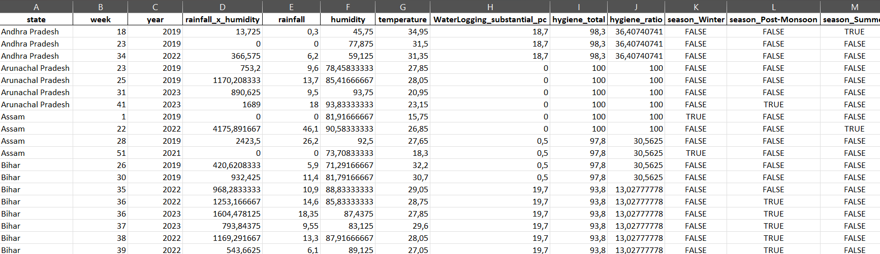

Model Used
-logistic regression
- decision tree
- XGBClassifier
- Random Forest Classifier( best perform)

Accuracy
Random Forest- 0.85 (best perform)
Decision tree-0.73
XGBClassifier-0.71
Logictic regression- 0.43
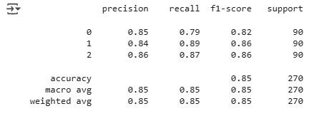

How to Run
1. Install requirements
2. Run app
3. Enter the state and the date for which you want prediction
Values for rainfall, humidity, temperature for future date is calculated by aggregating the previous 3 year data based on the location using openmeteo api but this api required input value in coordinates (latitude and longitude) so to calculate these values nominatim.openstreetmap.org is used then resultant coordinates feed to openmeteo as none api provide weather information for the date more then 7 days ahead
Values for WaterLogging_substantial_p', hygiene_total, hygiene_ratio is fetch through database as these values are static and no need to take input from user.
After prediction the new data and results are not stored in the database
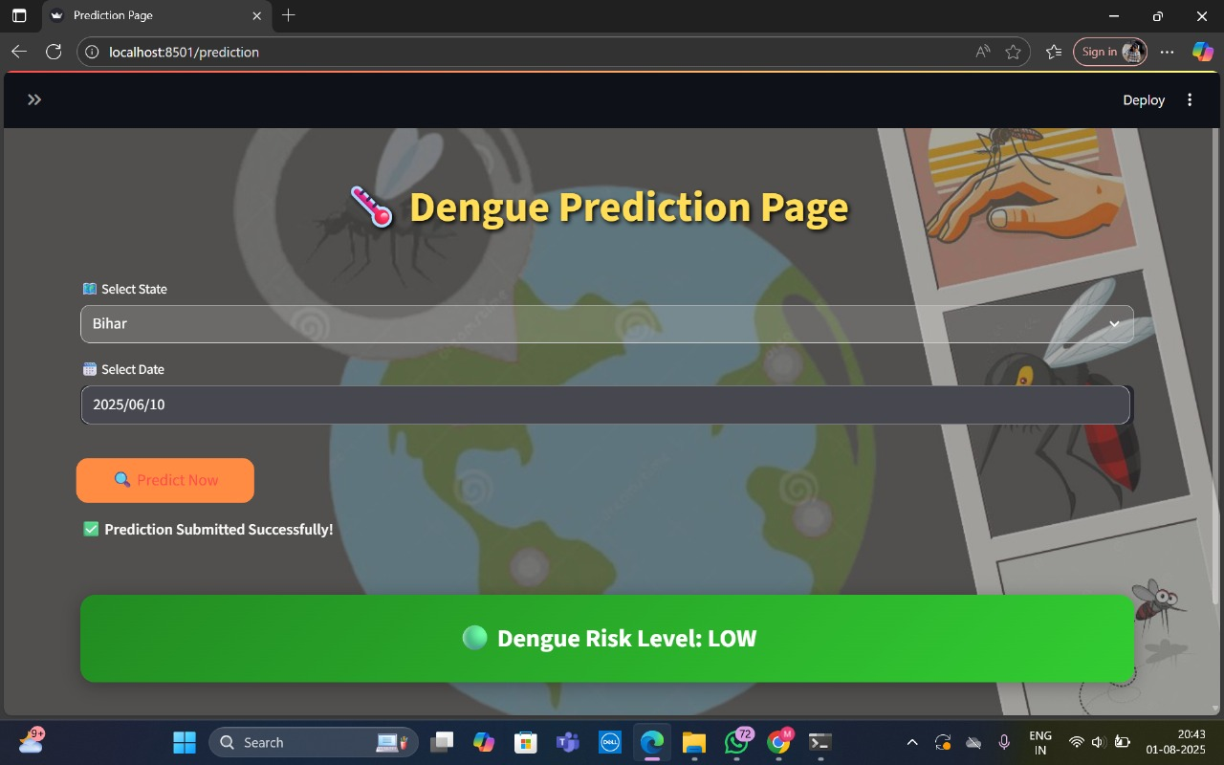

Future Scope
- Improve accuracy
- real time analysis

